# 

**E-VOTING SYSTEM**

**Project Report**

**<Version 1.0>**

Major Project (MCA 465)

Degree

**MASTER OF COMPUTER APPLICATION**



**COLLEGE OF COMPUTING SCIENCES AND INFORMATION TECHNOLOGY**

**TEERTHANKER MAHAVEER UNIVERSITY, MORADABAD**

May, 2023

|  |  |
| --- | --- |
| PROJECT GUIDE:  **Mr. Vineet Saxena** | SUBMITTED BY:  **Jayant Grover (TCA2163040)**  **Kashish Banga(TCA2163042)**  **Kritika Agarwal (TCA2163045)** |

**ACKNOWLEDGEMENT**

It gives us tremendous joy to start this E-VOTING SYSTEM project.

We are really appreciative of our project coordinator, Mr. Vineet Saxena at CCSIT, TMU.

Last but not least, we want to express our gratitude to those who aren’t mentioned by name but whom we rarely appreciate for their support and cooperation.

Without their individual assistance and meritorious expertise, this project would have not been successful. They were right behind us whenever we needed them.

However, this paper has been crafted with the utmost care and devotion. Even yet, we accept the respondent's flaws.

Jayant Grover

Kashish Banga

Kritika Agarwal

**Place: Moradabad**

**Date:**

**DECLARATION**

We hereby declare that this Project Report titled E-VOTING SYSTEM submitted by us and approved by our project guide, the College of Computing Sciences and Information Technology (CCSIT), Teerthanker Mahaveer University, Moradabad, is a bonafide work undertaken by us and it is not submitted to any other University or Institution for the award of any degree diploma / certificate or published any time before.

|  |  |  |  |  |  |
| --- | --- | --- | --- | --- | --- |
| **Project Group :** | G15 | | | | |
| **Student Name:** | Jayant Grover | | |  | |
| **Student Name:** | Kashish Banga | | |  | |
| **Student Name:** | Kritika Agarwal | | |  | |
| **Project Guide: (Internal)** | Mr. Vineet Saxena | | |  | |
|  | | |  | |  |
|  | |  |  |  |  |

**Brief About the Company**

**TEERTHANKER MAHAVEER UNIVERSITY**

**MORADABAD**

The university wants to be known as the ultimate location for top-notch education and is dedicated to upholding the values, right knowledge, and right conduct in all domains of endeavor. Here students have access to a special atmosphere where they may develop under the direction of knowledgeable faculty members and pick up the technical, artistic, and innovative abilities necessary to be employable.

# Project Title

E-VOTING SYSTEM

# Problem Statement

Paper ballots are used in traditional methods of conducting student elections, which are time-consuming, labor-intensive, and prone to errors. Furthermore, such methods lack transparency and are vulnerable to tampering, rendering the election process untrustworthy. Given these obstacles, there is an urgent need to create an electronic voting system that is efficient, secure, and transparent.

A web-based electronic voting system for student elections is what the proposed project seeks to design and create. Students may easily and securely cast their ballots using the system’s user-friendly interface. The data will be managed and the accuracy of the electron results will be guaranteed by the backend system. To guard against hacking and sorts of unwanted activities, the system will also have security features including encryption and authentication. The device will also increase openness by enabling authorized individuals to keep an eye on the voting process in real time.

The goal of this project is to develop a dependable, efficient, and a secure electronic voting system that will expedite the election process and boost the legitimacy of the results. Students will be able to vote remotely and securely under the proposed approach, boosting voter turnout and guaranteeing that every vote counts. Ultimately, by providing a platform for fair and transparent student elections, this initiative will help to develop digital democracy.

# Project Description

The goal of this project is to create a web-based, secure, effective, and transparent e-voting system for student elections. Students will be able to cast their votes remotely using their choice device and an internet connection from any location. The following attributes will be present in the suggested system:

* User Authentication: Using a unique login and password, the system will authenticate voters, guaranteeing that only approved students can vote.
* Candidate Information: The system will display information on the candidates, including their names.
* Voting Interface: The system will offer a user-friendly interface that makes it simple and accurate for students to cast their ballots.
* Real-time Monitoring: The technology will enable authorized staff to monitor the voting process in real-time, assuring accountability and transparency.
* Data Management: The system will securely manage voting data, assuring the accuracy of the election results.
* Security Measures: To avoid hacking and other harmful activity, the system will have security measures such as encryption and authentication.

Increased voter turnout, quicker election results, lower expenses, and greater transparency are just a few advantages of the planned e-voting system. The system will be scalable, making it possible to utilize it in elections for positions at different levels within the organization, such as class representatives, student council members, or faculty representatives. The suggested electronic voting method will, overall, strengthen digital democracy and increase the legitimacy of student elections.

## Scope of Work

The objective of this project is to create and develop a student election web-based e-voting system for student elections. Students will be able to vote remotely from any location using their choice device with an internet connection. The project’s scope of work will include the following:

* Collecting and recording the functional and non-functional requirements for the electronic voting system is known as requirement gathering.
* System Design: Creating the user interface, database schema, and system architecture for the electronic voting system.
* System Development: By utilizing current software development approaches, Django, Python.
* User Authentication: Using a unique username and password for each student to implement user authentication.
* Candidate Information: Information on the candidates, including their names, is displayed.
* Voting Interface: Creating a user-friendly interface that allows students to simply and properly cast their ballots.
* Creating a method for tracking the voting process in real time will ensure accountability and transparency.
* Data management: Creating a safe system to manage voting information and guarantee the validity of the results.
* Security measures: Putting security measures in place to stop hacking and other malicious acts, such as encryption and authentication.
* Testing and Quality Assurance: Testing and guaranteeing the system’s quality and dependability.

The creation of a web-based electronic voting system is the only activity covered under the project’s narrow scope, which excludes any hardware installation or configuration. The suggested electronic voting method will, overall, strengthen digital democracy and increase the legitimacy of student elections.

## Project Modules

* User management module: This module will be in charge of managing user accounts, including student registration, login, and password recovery. It will also ensure that the voting mechanism is only accessible by approved pupils.
* Candidate Management Module: This module will be in charge of handling candidate profiles, such as names and other pertinent information. It will also guarantee that the system displays only authorized applicants.
* Voting Module: This module is in charge of overseeing all aspects of voting, including the casting and recording of ballots. It will make sure that students can vote efficiently and properly, and it will also offer real-time voting process monitoring.
* Results management module: The responsibility for managing the election results, which involves their calculation and display, lies within the domain of results management. It will guarantee that the findings are transparent and accurate, and it will also offer real-time results monitoring.
* Security Module: This module will be in charge of assuring e-voting system security. To avoid hacking and other malicious acts, it will incorporate security mechanisms such as encryption, authentication, and access control.
* Reports Module: This module will generate reports on the voting process and results. It will enable authorized staff access to and analysis of data, providing transparency and accountability.
* Administration Module: The administration module is in charge of controlling the whole system, including user roles, system preferences, and system upkeep. It will guarantee that the electronic voting system is efficient, dependable, and current.

## Context Diagram (High Level)

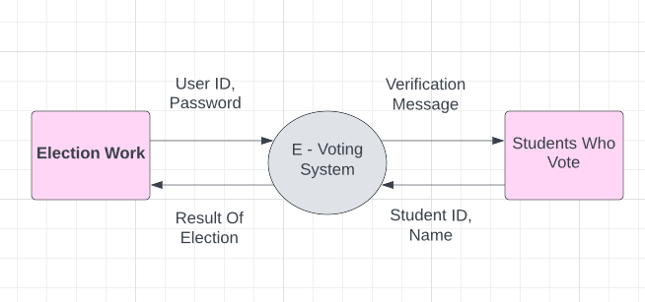

# Implementation Methodology

**CONTEXT DIAGRAM**



**DFD-1**

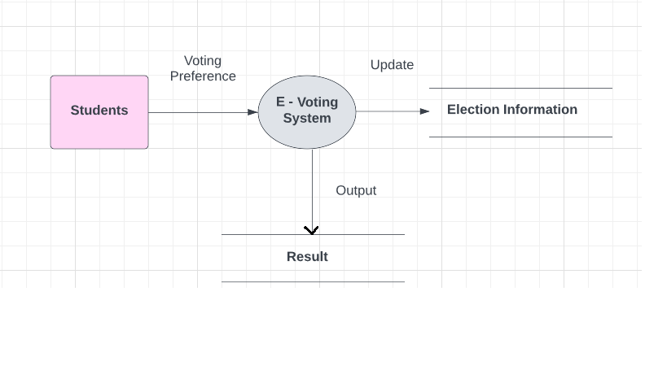

**DFD-2**

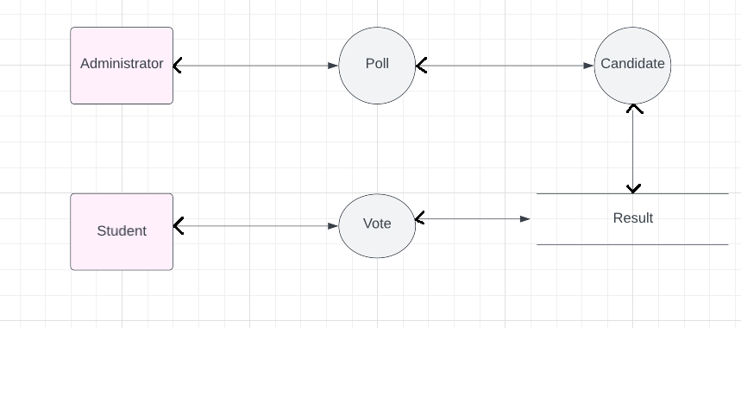

**DFD-3**

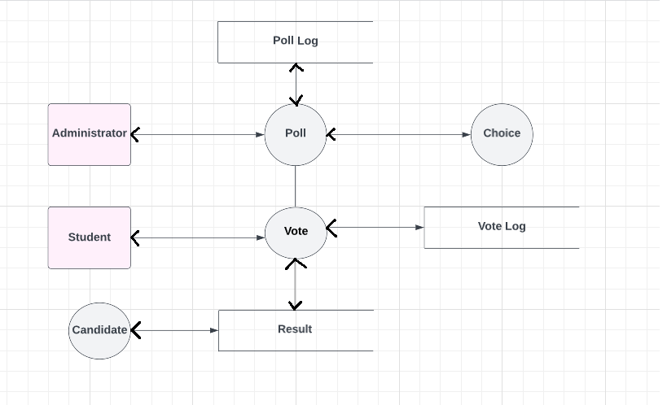

**ERD DIAGRAM**

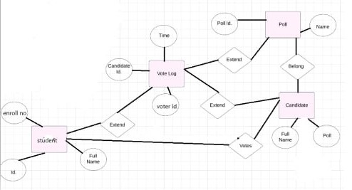

**FLOW CHART**

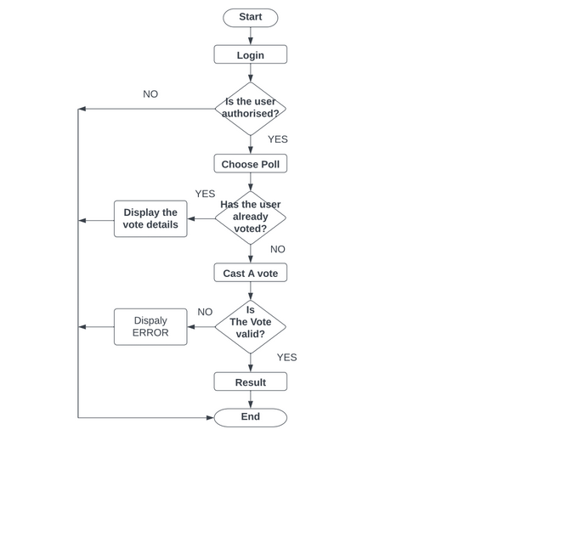

**USE-CASE DIAGRAM**

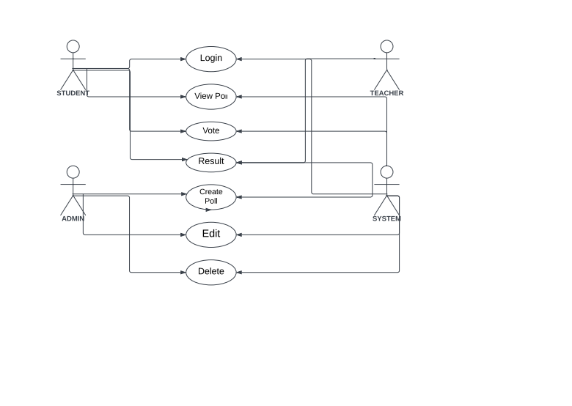

# Technologies to be used

* 1. **Software platform**

1. **Front-end**

HTML

JAVASCRIPT

1. **Back-end**

PYTHON

DJANGO

* 1. **Hardware platform**

RAM- 8 GB

Hard Disk- 512GB

OS- WINDOW 10, 11

Editor- VS CODE

Browser- CHROME

## Tools, if any

VS CODE

# Advantages of this Project

* Improved Accessibility: The electronic voting method will make voting more accessible and convenient for students. Students may vote from anywhere using any device with an internet connection, saving them time and effort.
* Improved Participation: Because it eliminates the need to physically attend the polling place, the e-voting method will encourage more students to vote in the elections. This will improve student participation in the election process, resulting in a more representative and democratic result.
* Improved transparency: The e-voting system will monitor the voting process and outcomes in real time, assuring openness and accountability. Students may track the progress of the election. The election authorities play a crucial role in implementing standardized procedures to safeguard the integrity of the voting process and ensure accurate vote counting.
* Efficiency Gains: Because the e-voting technology automates numerous manual procedures, it will take less time and work to execute the election. Election authorities will have less work to do as a result, and the results will be made accessible more swiftly.
* Improved Security: To stop hacking and other nefarious acts, the electronic voting system will integrate security measures including encryption and authentication. This will secure the privacy of student voters and assure the accuracy of the election results.

# Assumptions, if any

ZLICH

# Future Scope and further enhancement of Project

* Mobile Application: As part of its future development, the project aims to extend its capabilities by incorporating a mobile application into the e-voting system. Students will be able to vote using their smart phones and tablets, giving them even greater freedom and convenience.
* Facial recognition: Technology for facial recognition is another improvement to the electronic voting process. By using a picture to prove their identity, students will be able to do away the laborious identification procedures.

# Project Repository Location

| **S#** | **Project Artifacts** | **Location** | **Verified by Project Guide** | **Verified by Lab In-Charge** |
| --- | --- | --- | --- | --- |
|  | Project Synopsis Report |  |  |  |
|  | Project Progress updates |  |  |  |
|  | Project Requirement specifications |  |  |  |
|  | Project Report |  |  |  |
|  | Test Repository |  |  |  |
|  | Any other document, give details |  |  |  |

# Definitions, Acronyms, and Abbreviations

|  |  |
| --- | --- |
| **Abbreviation** | **Description** |
| SRS | Software Requirement Specification |
| VS CODE | Visual studio |

# Conclusion

Finally, the e-voting system for student elections represents a substantial improvement in the election process, offering various advantages over traditional paper-based voting methods. The implementation of this technology will lead to improved accessibility, increased participation, enhanced transparency, streamlined efficiency, and heightened security in student elections.

Among the project components of the e-voting system are voter registration, candidate nomination, and vote casting. The technology may be improved further using mobile applications and facial recognition.

The use of an electronic voting system will guarantee that student elections are handled in a democratic, open, and reliable manner. More students will take part in the election as a result, resulting in more representative conclusion. The approach will also conserve time, money, and resources, making student elections more affordable and effective.

The e-voting system for student elections, in its entirety, makes a substantial contribution to the education sector by encouraging student engagement, democratic principles, and technological improvements.

# References

|  |  |  |  |  |
| --- | --- | --- | --- | --- |
| **S#** | **Reference Details** | **Owner** | **Version** | **Date** |
|  | https://www.electionsonline.com/online-voting-system/ | Election online |  |  |
|  | <https://en.wikipedia.org/wiki/Electronic_voting> | Wikipedia |  |  |
|  | https://jpinfotech.org/online-election-system-online-voting-system/ | Jpinfotech |  |  |

**Annexure A**

**Data Flow Diagram (DFD)**

**(Mandatory)**

**0-LEVEL**



**1-LEVEL**



**LEVEL - 2**



**LEVEL- 3**



**Annexure B**

**Entity-Relationship Diagram (ERD)**

**(Mandatory)**



**Annexure C**

**Flow chart**



**Annexure D**

**Use-Case Diagram (UCD)**



**Annexure E**

**Data Dictionary (DD)**

**(Mandatory)**

**Example:**

**User Table (USR)**

|  |  |  |
| --- | --- | --- |
| **Fields** | **Data type** | **Description** |
| USER-ID | Int | Unique number id for all users |
| USER-UserName | Text | Unique enrollment number |
| USER-FirstName | Text | User FirstName |
| USER-LastName | Text | User LastName |
| USER-Email Id | Text | User Email Id |
| USER-Password | Text | User Password |

**Annexure F**

**Screen Shots**

**Home Page:**



